Using JBuilder with JBoss
This chapter explains how set up and use the JBoss application server with JBuilder. JBuilder officially supports JBoss 3.2.1 and JBoss 3.0.7.

Configuring JBuilder for the JBoss application server
To configure JBuilder settings to target JBoss servers,
- Choose Tools|Configure Servers.
The Configure Servers dialog box appears.
- Select the JBoss server you want to configure by clicking it in the pane on the left.
The right side of the dialog box lists the default settings for the selected server. The General page has fields that all servers have in common, while the Custom page has fields that are specific to the selected server. In some cases, modifying a Custom setting will update a setting on the General page.
- Check the Enable Server check box at the top of the dialog box.
Checking this option enables the fields for the selected application server. You won't be able to edit any fields until it is checked. The Enable Server check box also determines whether this server will appear in the list of servers when you select a server for your project using the Servers page of the Project|Project Properties dialog box.
JBuilder provides default settings for the selected server. If JBuilder's default settings are not appropriate, edit any of the settings as needed. Some servers require you to enter settings in addition to the defaults. Clicking the OK button in this dialog box when not all required values are set or selecting another server while the current one is enabled displays a message dialog box that informs you about the missing settings.
- If you want to change any of the settings, click the ellipsis (…) button next to the field and make your changes. If you installed JBoss into [drive]:/jboss321, for example, the default Home Directory would be [drive]:/jboss321/jboss-3.2.1.
- Click the Custom tab to view fields unique to the server. Change or fill in these fields:
  - Server Version: Your choices are server version 3.2x and 3.0x. These are the versions of JBoss JBuilder officially supports.
  - Configuration Name: Specify the configuration you want to begin using. You can select a configuration from the drop-down list, or type in your own configuration name. The configuration you specify must exist in the server directory, which is a subdirectory of the Home directory.
  - Deployment Path: Specify the path used to deploy your modules. By default, the deployment path will be in the deploy subdirectory of the directory you specified as the Configuration Name.
  - Include System Modules When Listing Deployments: JBuilder can list all your deployed modules. If you wish to see the system modules such as the the web container or the EJB container and other services that are a core part of the JBoss server, check this option.
  - Include Disabled Modules When Listing Deployments. JBuilder can list all your deployed modules. If you wish to see modules which are currently disabled, check this option. A disabled module is simply one that has been renamed to <module name>.disabled when you choose to disable it within JBuilder using the Disable deployment option.
- Choose OK to close the dialog box and configure JBuilder.
When you configure JBuilder to target a JBoss server, required libraries are created for you. To see a list of the JBoss libraries, see "The created libraries."

Selecting a server
If you are working with more than one version of JBoss Application Server and have configured JBuilder for all versions, you must select which version you want to use for your current project. Choose Project|Project Properties and select Server in the tree to display the Server page. See "Selecting a server" in "Configuring the target application server settings" for more information.

Creating a JBoss service module
You can use JBoss to create a service module for extending the JBoss server. A service module contains the definition of a service. Once you compile the service module, a service archive (SAR) is created, ready to be deployed to JBoss.
To create a service module within JBuilder, follow these steps:
- Choose File|New|Enterprise and double-click the JBoss Service Module wizard. The wizard appears:
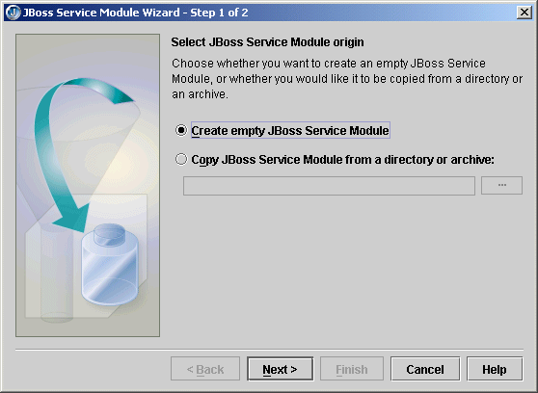
- Decide if you are creating an empty service module or if you are creating one from an existing service and just want it copied from a specified directory or archive. If you are creating an empty service module (your service doesn't exist yet), select the Create Empty Service Module. If the service already exists, select the Copy JBoss Service Module From A Directory Or Archive, and use the ellipsis (…) button to browse to the location of the directory or archive that contains the service you want in the service module you are creating. Click Next to go to the next step.
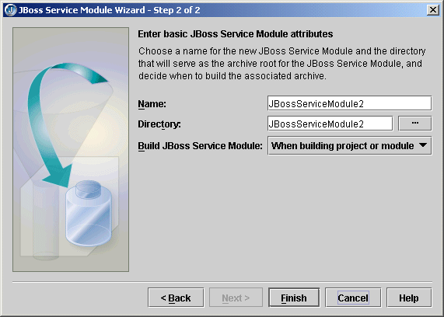
- Specify the name of the service module. You can accept the default name JBuilder gives the module, but you'll probably choose to specify a more meaningful name.
- Specify the directory underneath the project directory where you want the service module created.
- Specify when you want the service module built using the drop-down list.
- Click Finish to create the JBoss service module.

Editing the JBoss service module deployment descriptor
Once you've created a JBoss service module, you edit the module's deployment descriptor using JBuilder's JBoss Service Module DD Editor. To display the editor, double-click the new service module that appears in the project pane:
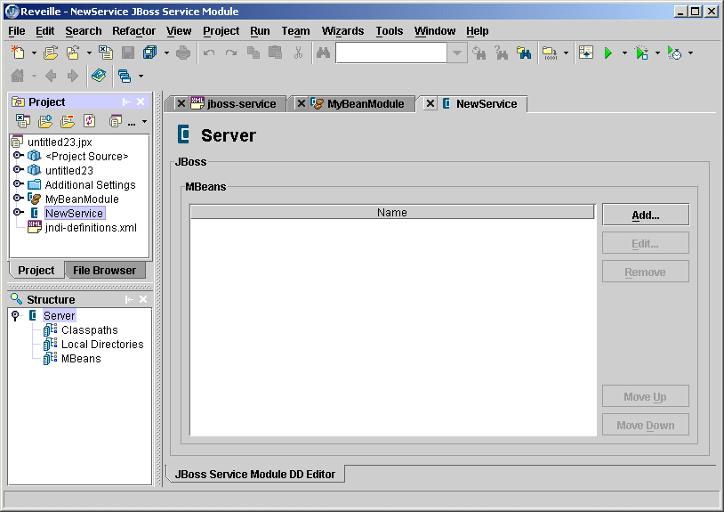
Now you can customize the service module deployment descriptor (jboss-service.xml) with the values you need for your new service. The JBoss Service Module DD Editor works just like the other J2EE DD Editors in JBuilder. To learn how to add pages and edit them in the DD Editor, see "Editing J2EE deployment descriptors."
In the structure pane, you can see that their are JBoss-specific nodes for Classpaths, Local Directories, and MBeans. Add a Classpath, Local Directory, or MBean by right-clicking the category of the item you are adding and choosing Add on the context menu that appears. Then double-click that new entry in the structure pane to display a page for it in the JBoss Service Module DD Editor. For assistance filling in the fields on these pages, display the page and press F1. You'll find JBoss documentation useful in filling in the fields, too.
At any time you can view the jboss-service.xml descriptor in its source form. Expand the service module node in the project pane to see the Deployment Descriptors node and then expand that node too. The jboss-service.xml node becomes visible. Double-click it to see the it in the content pane. You can edit the file by hand, if you wish.

MBeans
All JBoss services are in MBeans. So your service module will have one or more MBeans. Once you've added an MBean entry to the module, expand the entry in the structure pane to see Attributes, Depends Items, and Depends Lists nodes. Add entries to these categories by right-clicking them and choosing Add. Press F1 for help filling in the fields.

Starting the server
To prepare to start the server from within JBuilder, create a server runtime configuration. Follow these steps:
- Choose Run|Configurations.
- In the dialog box that appears, click the New button.
- Select Server from the Type drop-down list.
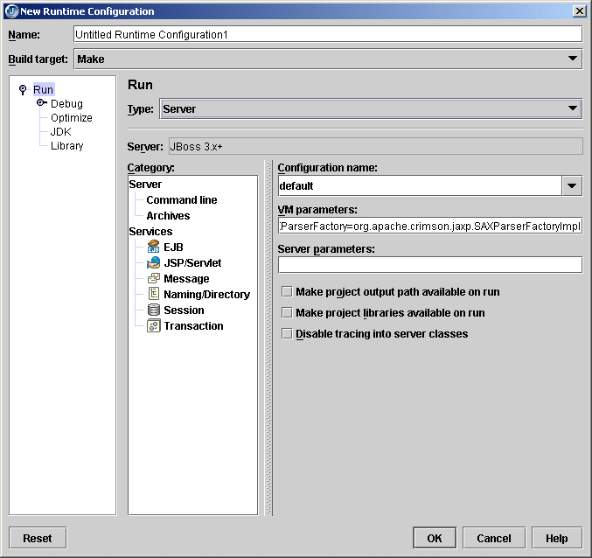
- In the Name field, enter a name, such as Server or something that will identify the run configuration.
- Fill in the VM Parameters and Server Parameters needed to run the server. If you've selected a target application server as described in "Selecting a server," default values are already in place.
- Click OK.
To start the server, click the down-arrow next to the Run Project icon () and select the server run configuration you just created.

Deploying locally
To deploy a deployable module to a local server, choose one of these options:
- Using the Tools|Server Deployment command:
  - Choose Tools|Server Deployment to display the JBoss 3.x+ Deploy Settings dialog box.
  - From the Action drop-down list, select Deploy.
  - Select the archive to deploy from the drop-down Archive To Deploy list or browse to the archive you want to deploy using the ellipsis (…) button.
  - Specify the correct deployment path for JBoss Server. Accept the default value or browse to the correct directory using the ellipsis (…) button.
  - Choose OK.
- Deploying from the project pane:
  - Right-click the module you want to deploy in the project pane and choose Properties.
  - Select Deployment in the tree to display the Deployment page.
  - Specify the correct deployment path for JBoss Server. Accept the default value or browse to the correct directory using the ellipsis (…) button.
  - Choose OK.
  - Right-click the module you want to deploy in the project pane and choose Deploy Options|Deploy.
Both the Server Deployment dialog box and the Deployment page of the Project|Project Properties dialog box have these two options:
- Include System Modules When Listing Deployments
- Include Disabled Modules When Listing Deployments
These options allow you to fine tune what you see when you list deployments using either the List Deployments action in the Server Deployment dialog box or when you right-click a module and choose Deploy Options|List Deployments. Listed deployments appear in a tree in the message pane. A system module is one that is that extends the server and provides a service your modules can use. A disabled module is one you mark as Disabled by right-clicking the module and choosing Deploy Options|Disable. When a module is disabled, it is simply renamed to <module>.disabled. To enable a module again, right-click the module and choose Deploy Options|Enable.

Remote debugging
Within JBuilder, follow these steps:
- In the project from which you want to launch the remote debug session, click Run|Configurations. If you have not yet created a server type run configuration, click New and select type Server. If you have already created a server type run configuration, select it and choose Edit.
- Select Debug|Remote in the tree.
- Check the Enable Remote Debugging option.
- Enter the host name (the name of the machine on which the server is running.)
- Specify the correct port number for the remote server.
- Click OK.
- Click the down arrow next to the Debug Project icon () on the JBuilder toolbar and select the debug run configuration you just created or edited. You will now be able to set breakpoints in Java code, such as in EJBs, servlets, and so on.

JSP debugging
Tomcat or Jetty do not support JSP source debugging, but you can remedy this problem with the following steps:
- Browse to the <jbuilder>/thirdparty/jakarta-tomcat-4.0.6-LE-jdk14/lib directory.
- For Tomcat, copy jasper-compiler.jar and jasper-runtime.jar to the <jbuilder>/thirdparty/jakarta-tomcat-4.1.24-LE-jdk14/common/lib directory.
- For Jetty, search for the jasper-compiler.jar and the jasper-runtime.jar in your JBoss installation and replace them with the jasper-compiler.jar and the jasper-runtime.jar found in the <jbuilder>/thirdparty/jakarta-tomcat-4.0.6-LE-jdk14/lib directory.
For more information about JSP debugging, see "Debugging JSPs" in the "JavaServer Pages (JSP)" chapter of the Web Application Developer's Guide.

